1. Create a class Person with attributes name and age. Write a method to display this information.
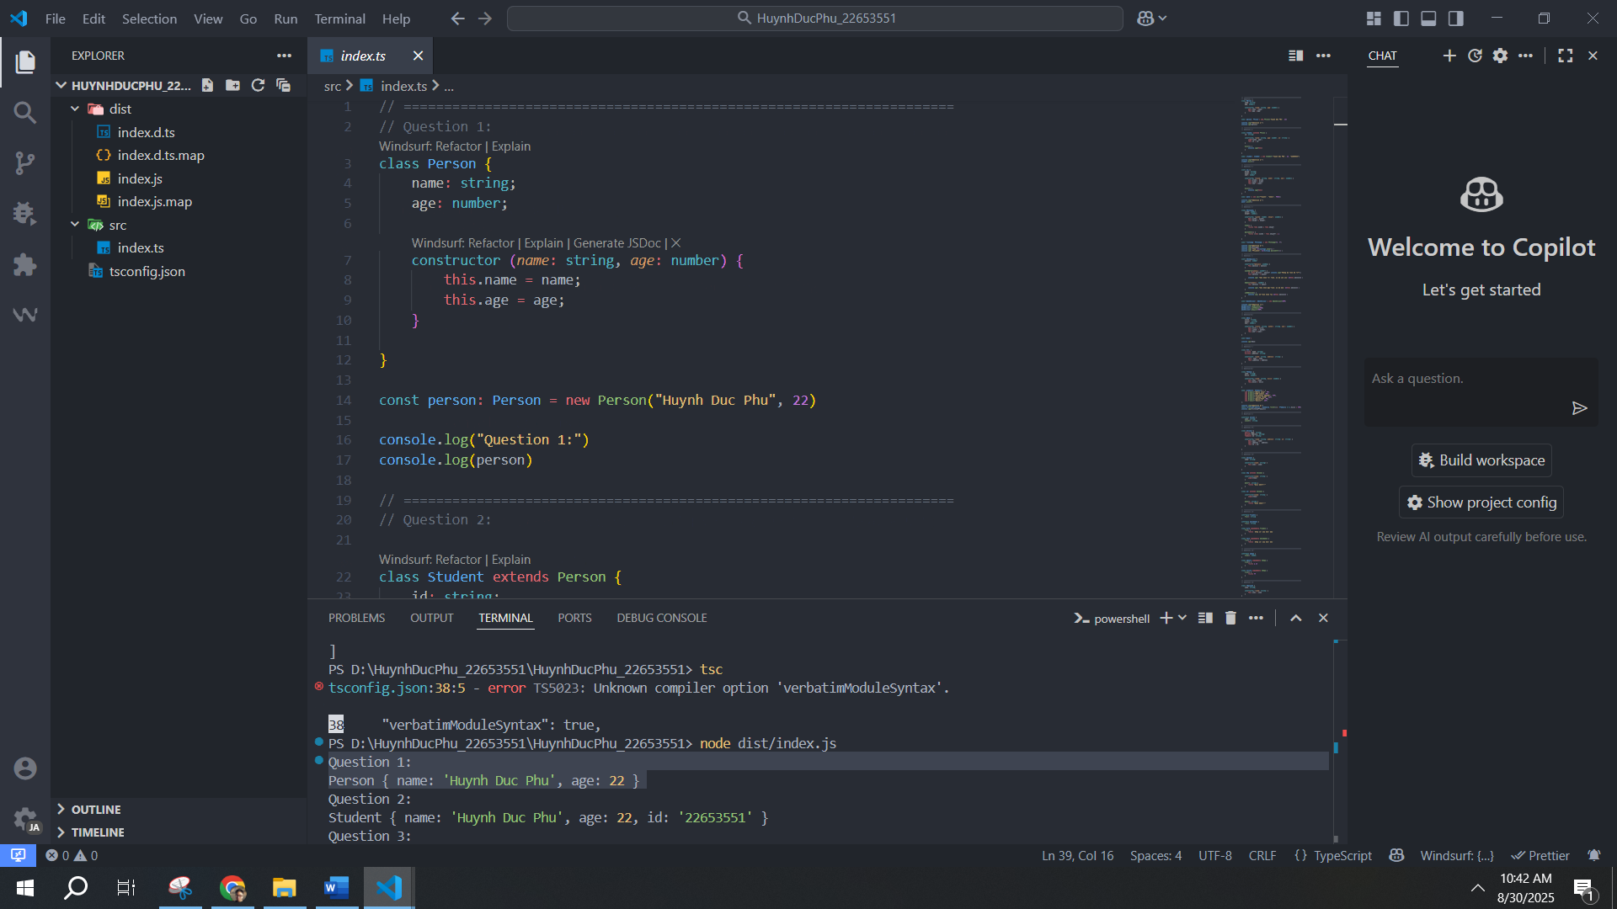
2. Write a class Student extending Person with an additional attribute grade. Add a method to display all info.
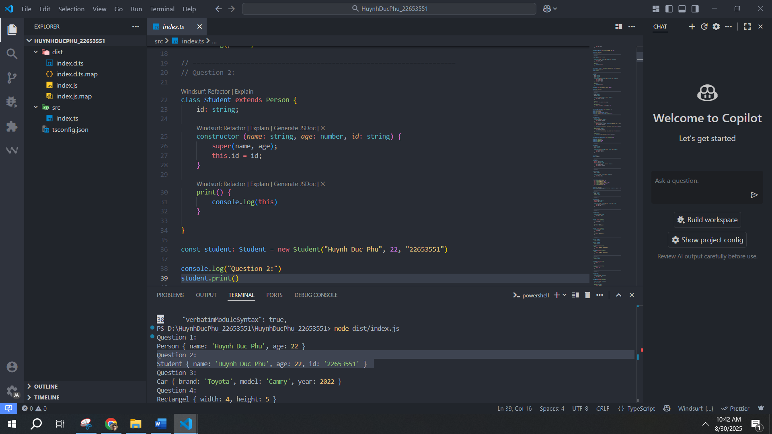
3. Create a class Car with properties brand, model, year. Write a method to show car info.
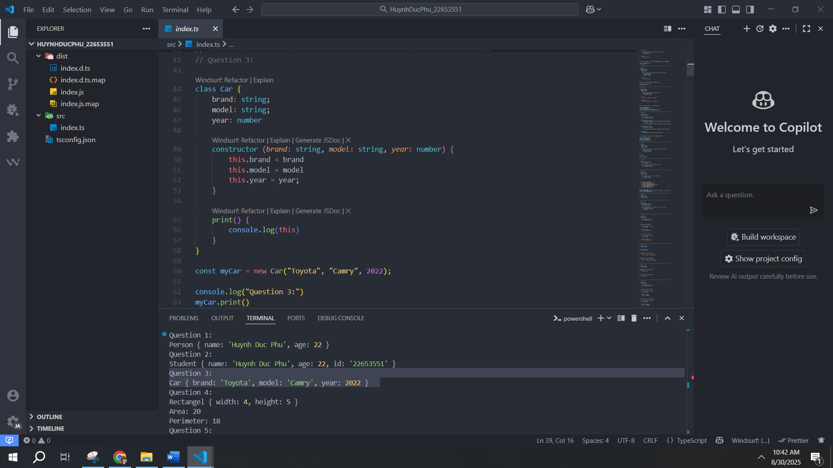
4. Create a class Rectangle with width and height. Write a method to calculate area and perimeter.
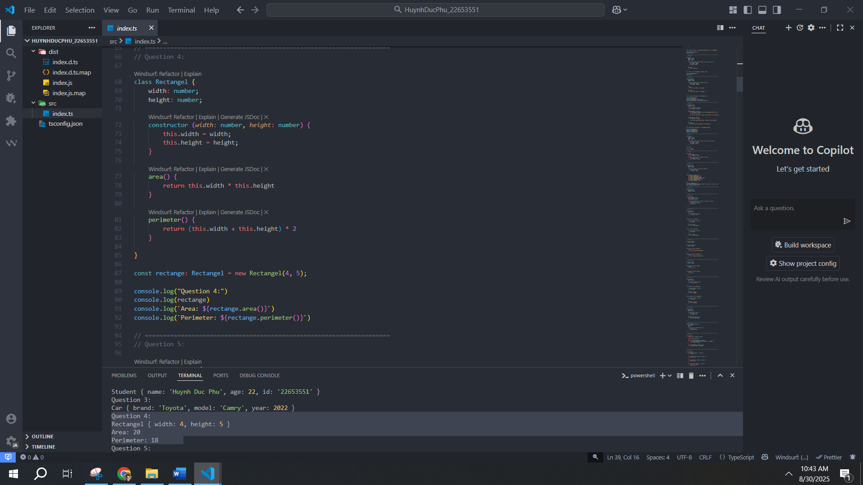
5. Create a class BankAccount with balance. Add methods deposit() and withdraw().
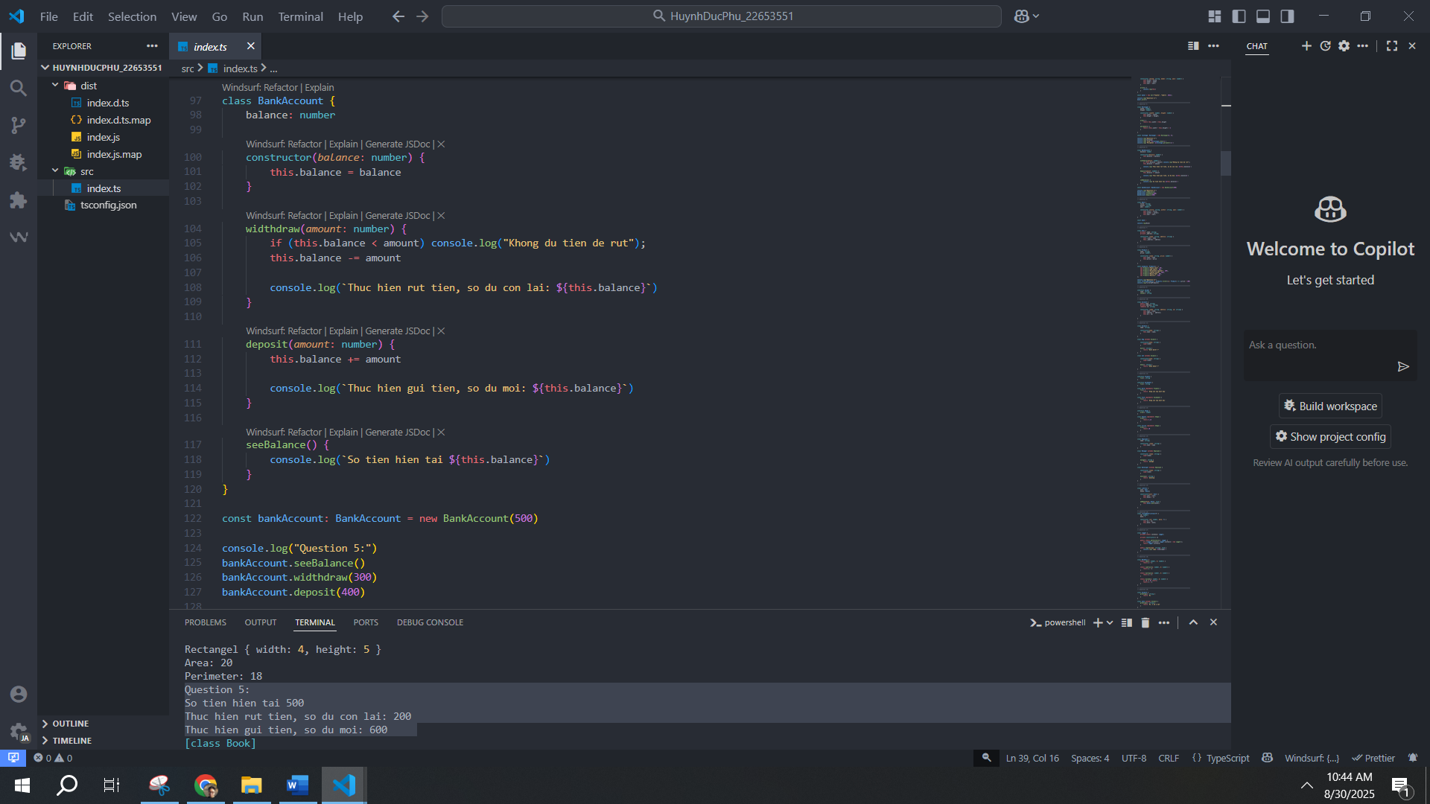
6. Create a class Book with attributes title, author, year.
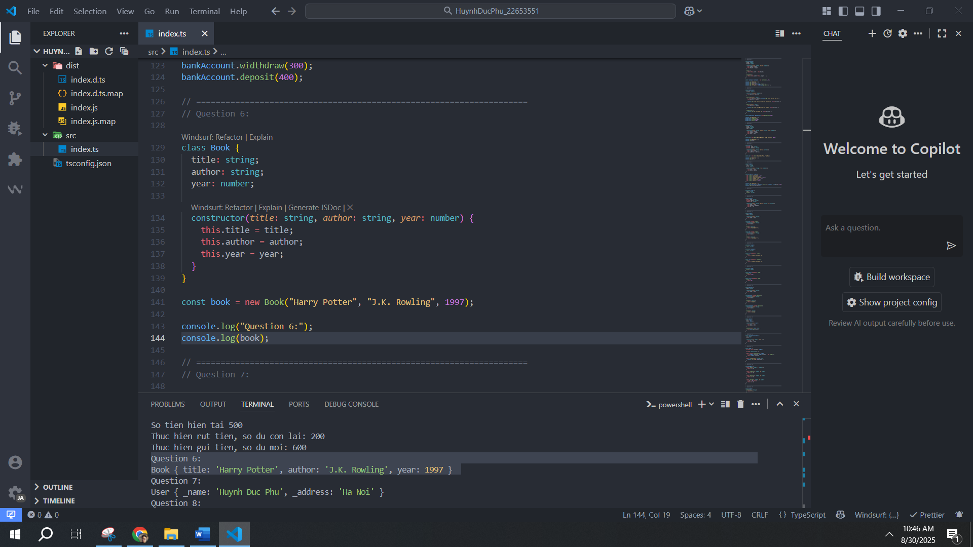
7. Write a class User with private property name and getter/setter.
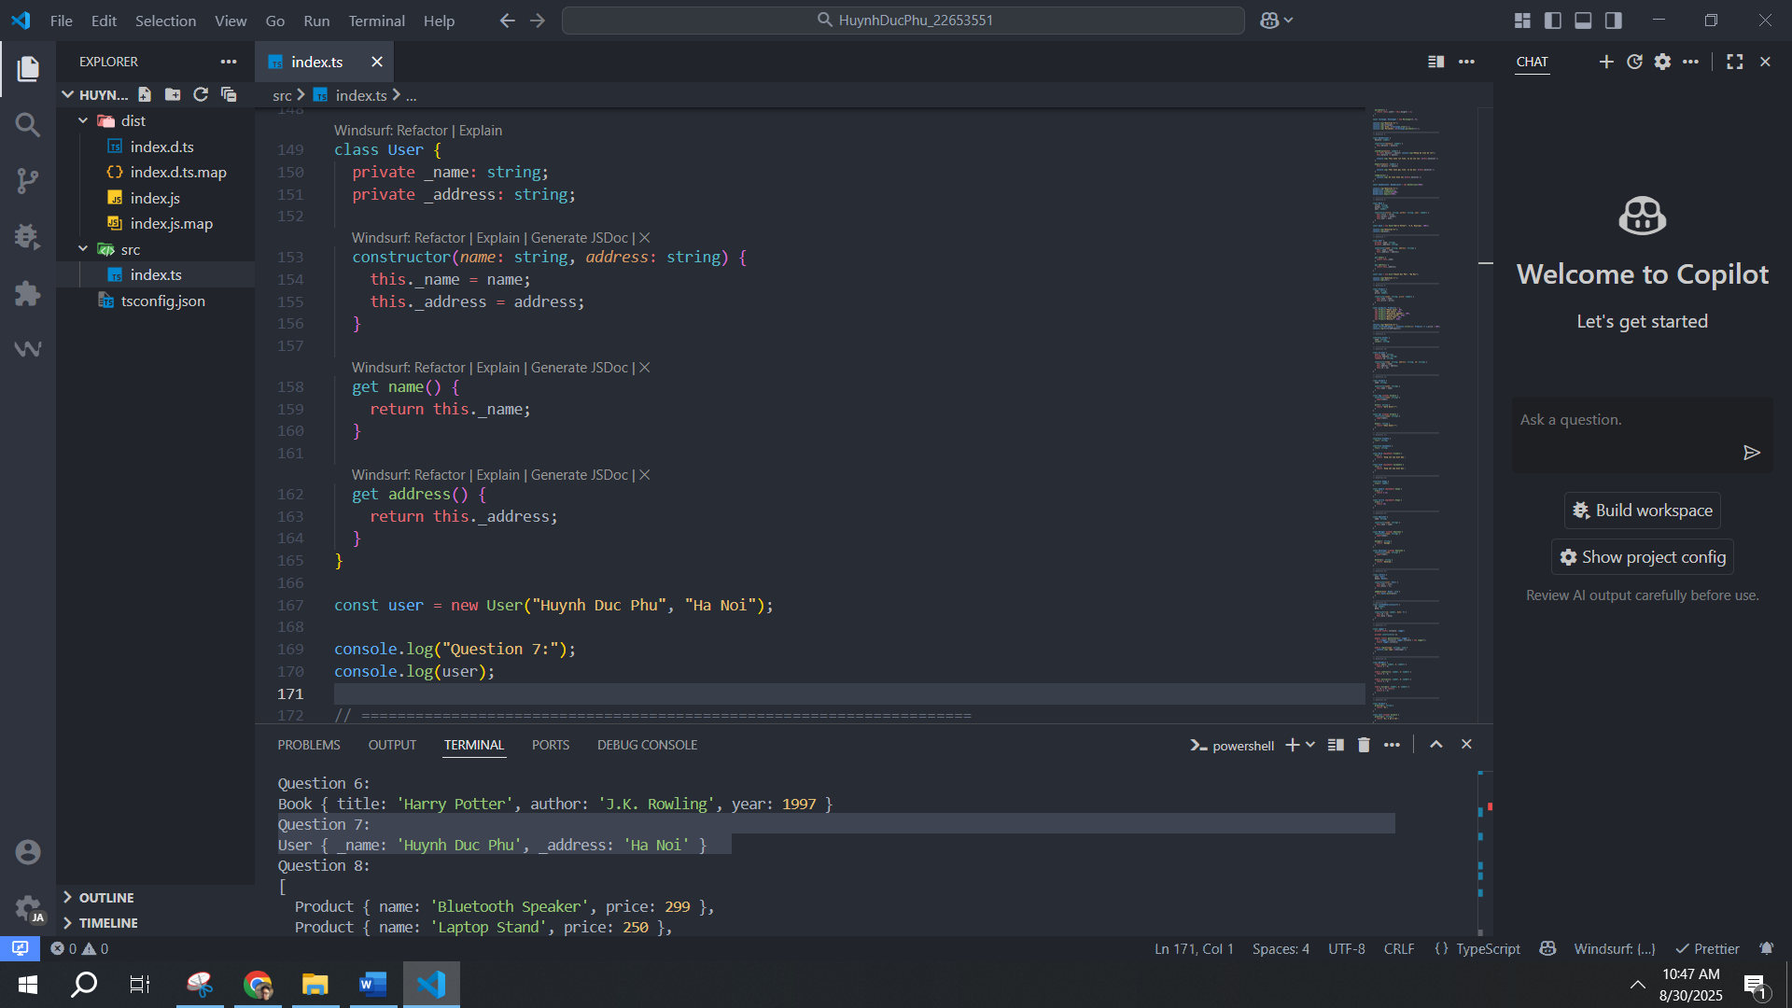
8. Create a Product class with name, price. Create an array of products and filter products with price > 100.
9. Define an interface Animal with name and method sound().
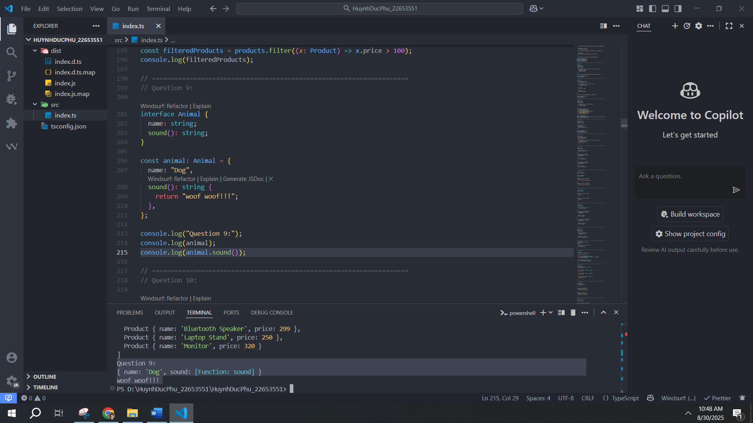
10. Create a class Account with public, private and readonly fields.
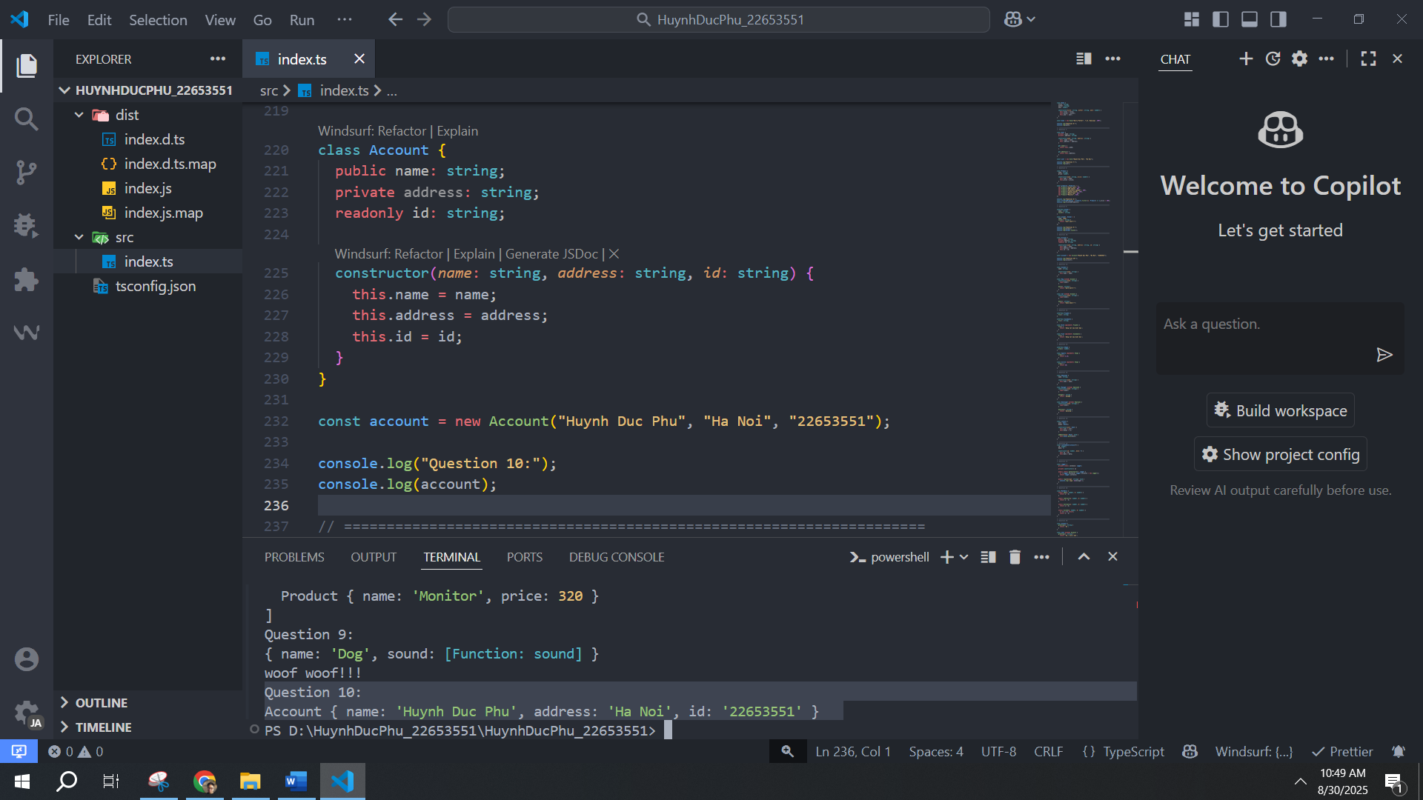
11. Create a base class Animal. Extend Dog and Cat classes with methods bark() and meow().
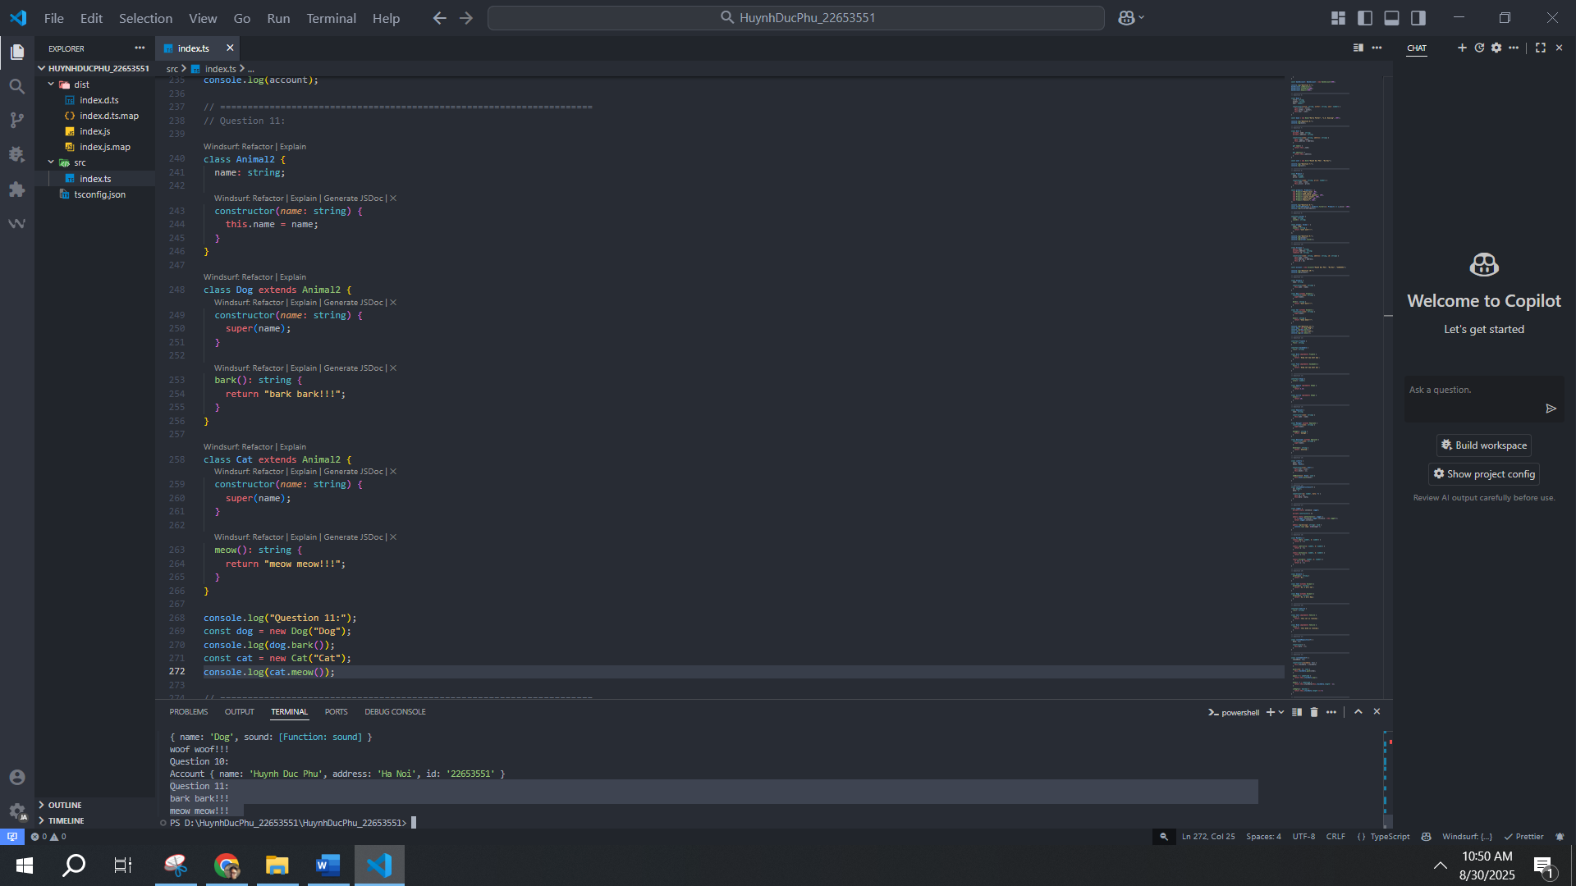
12. Define interfaces Flyable and Swimmable. Implement them in Bird and Fish classes.
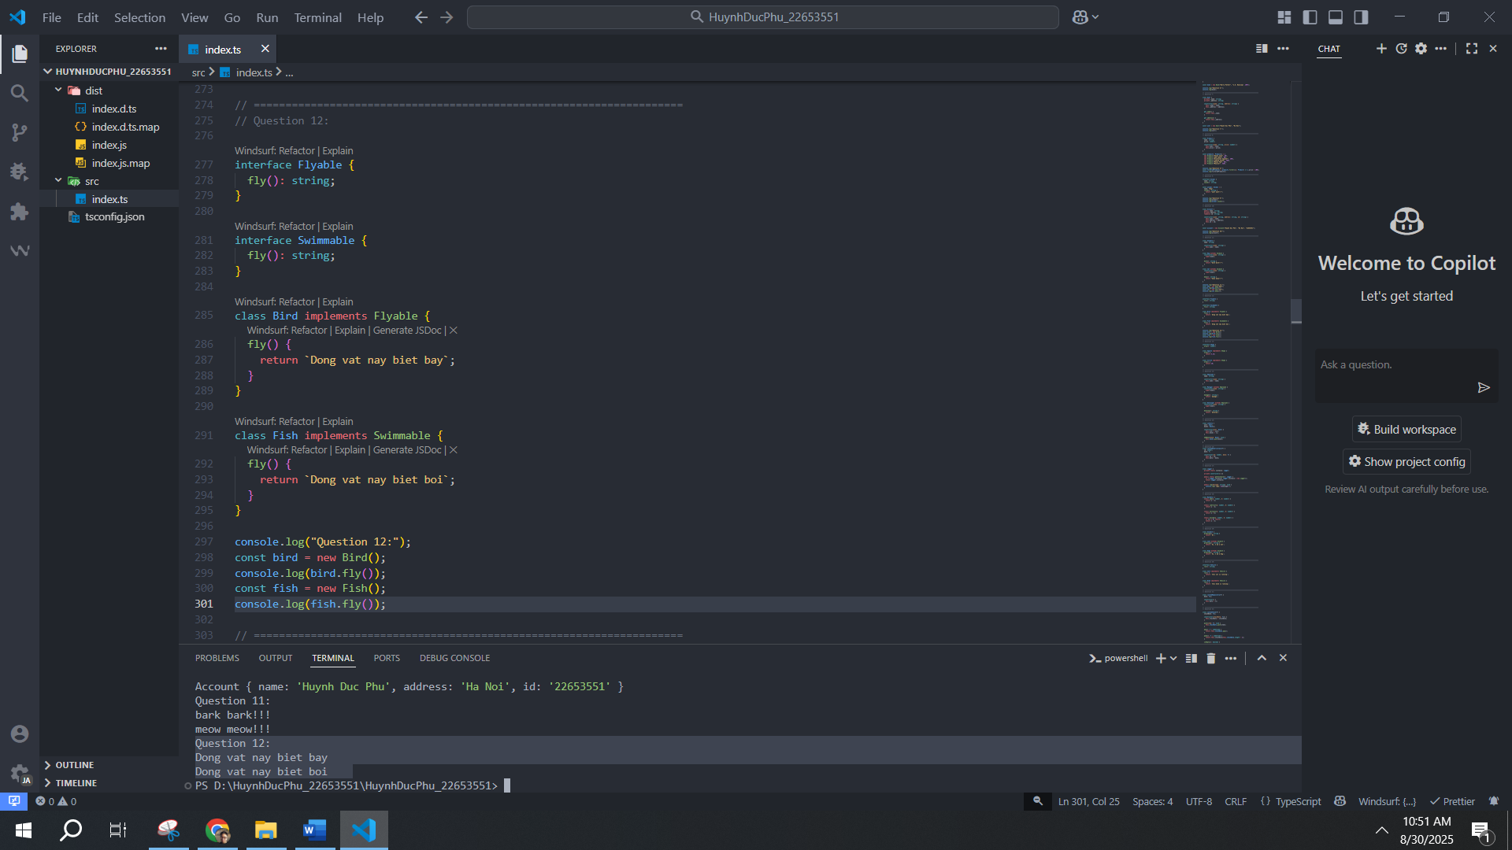
13. Create an abstract class Shape with method area(). Implement Square and Circle.
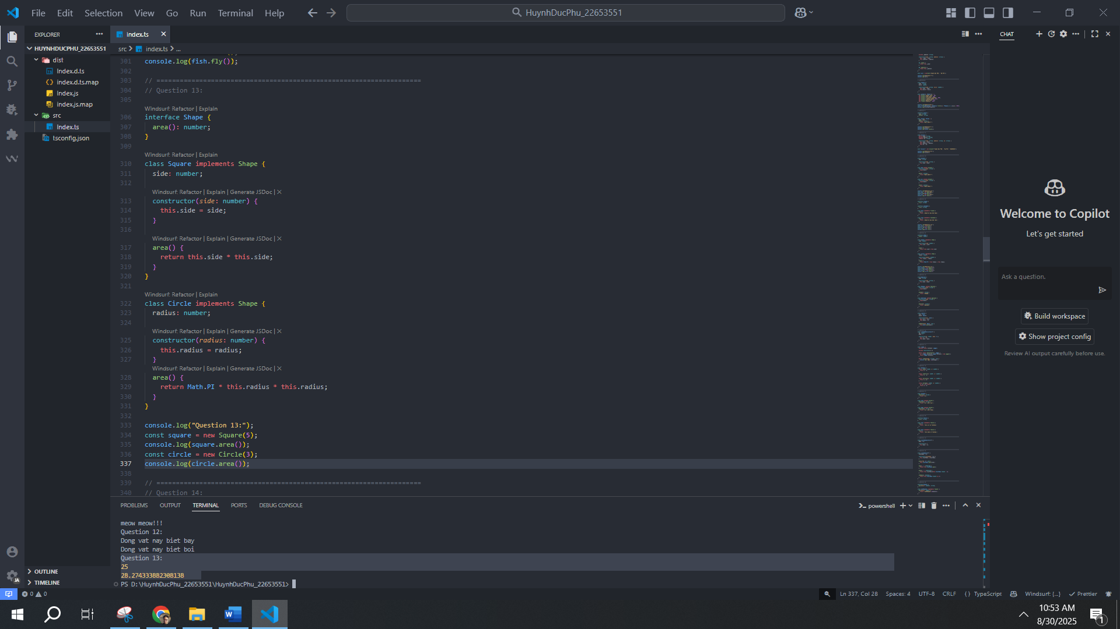
14. Create a base class Employee. Extend Manager and Developer with specific methods.
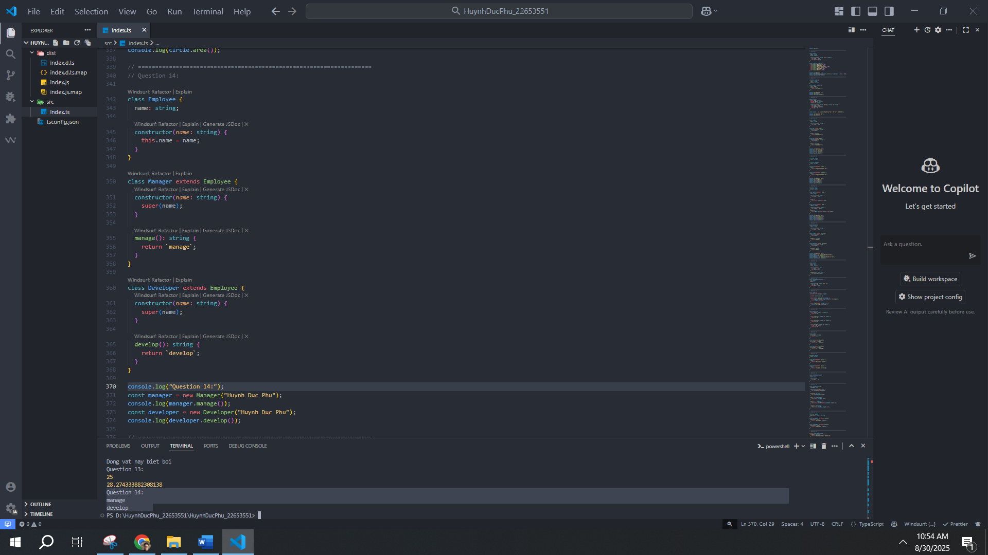
15. Create a Library class that can store Book and User objects. Add method to add books.
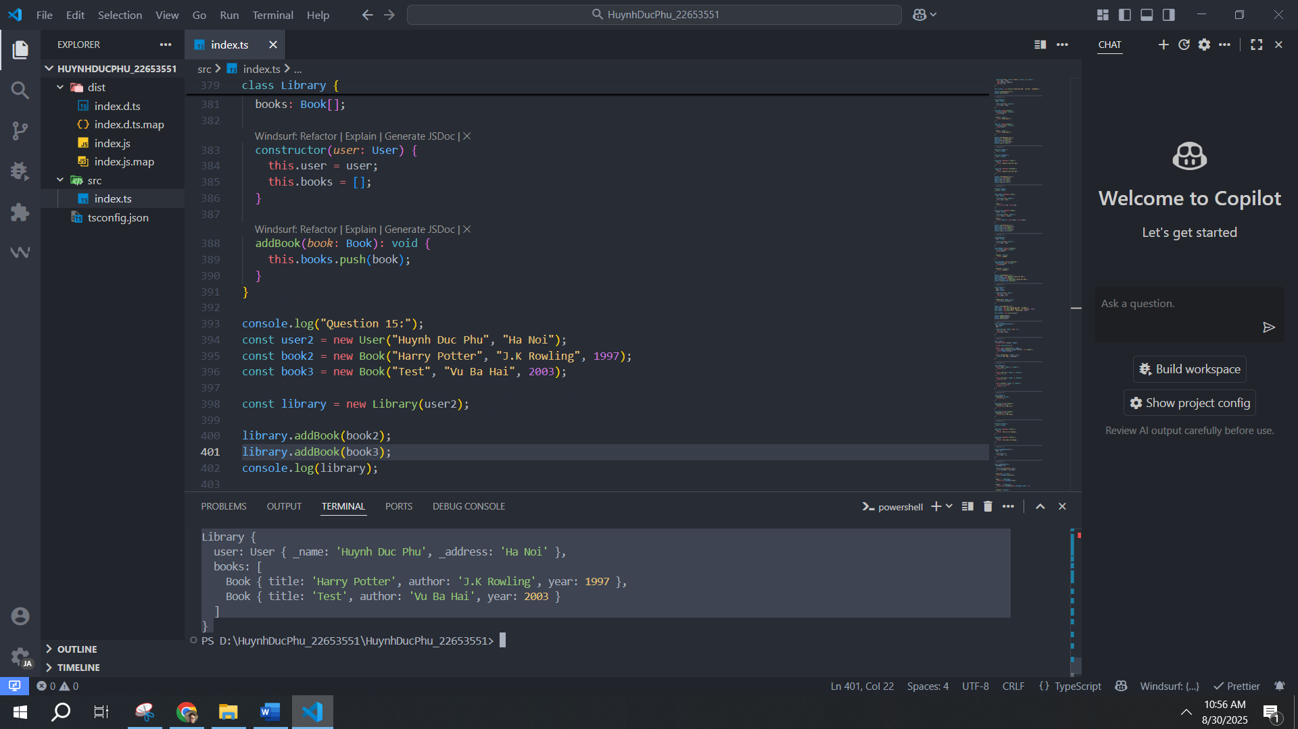
16. Create a generic class Box that can store any type of value.
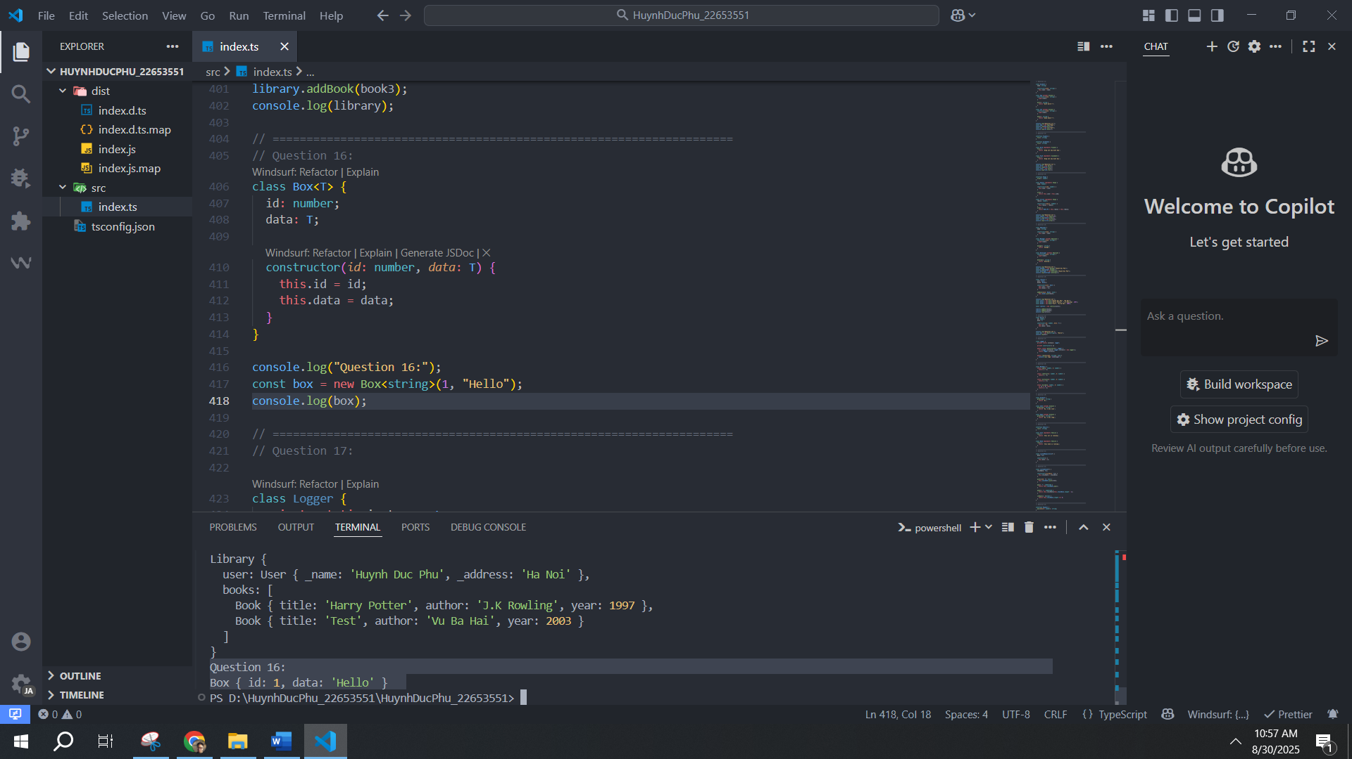
17. Write a singleton Logger class that logs messages to console.
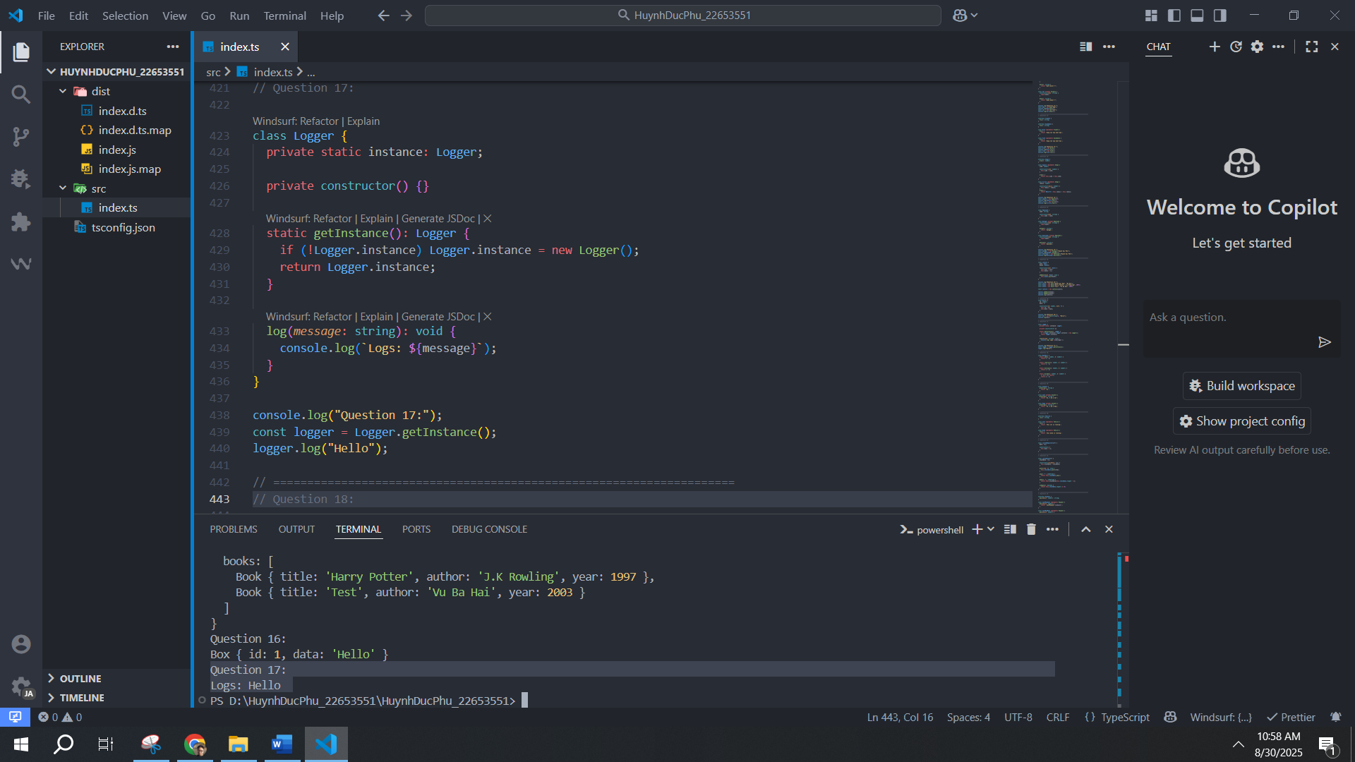
18. Create a static class MathUtil with methods add(), subtract(), multiply(), divide().
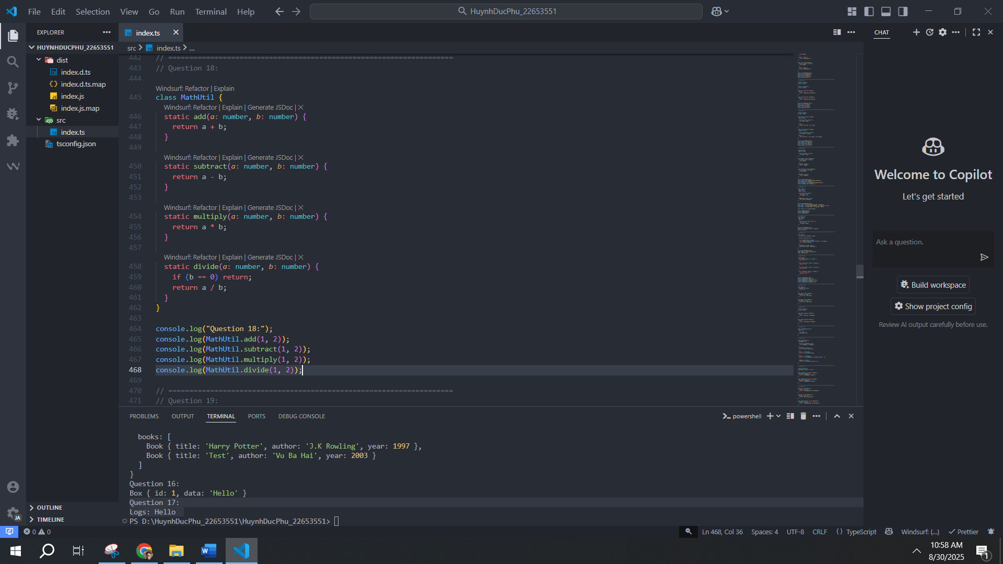
19. Demonstrate method overriding using polymorphism with Animal and subclasses.
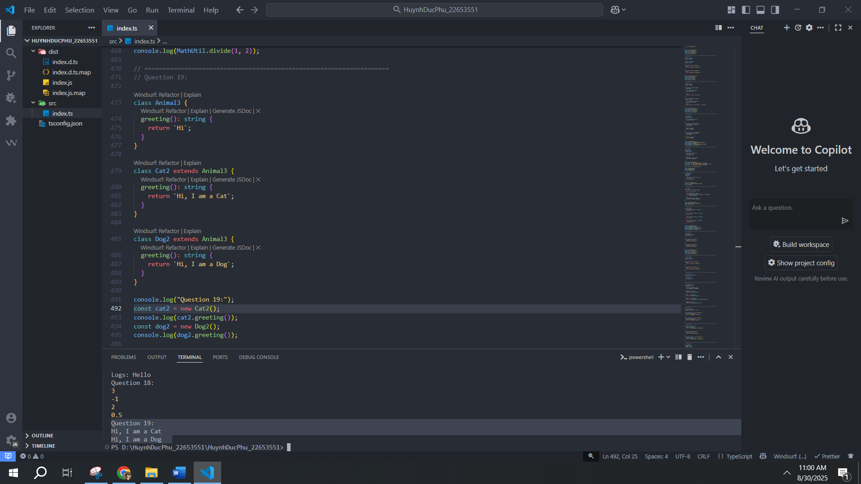
20. Write a Vehicle interface and implement it in Car and Bike classes.
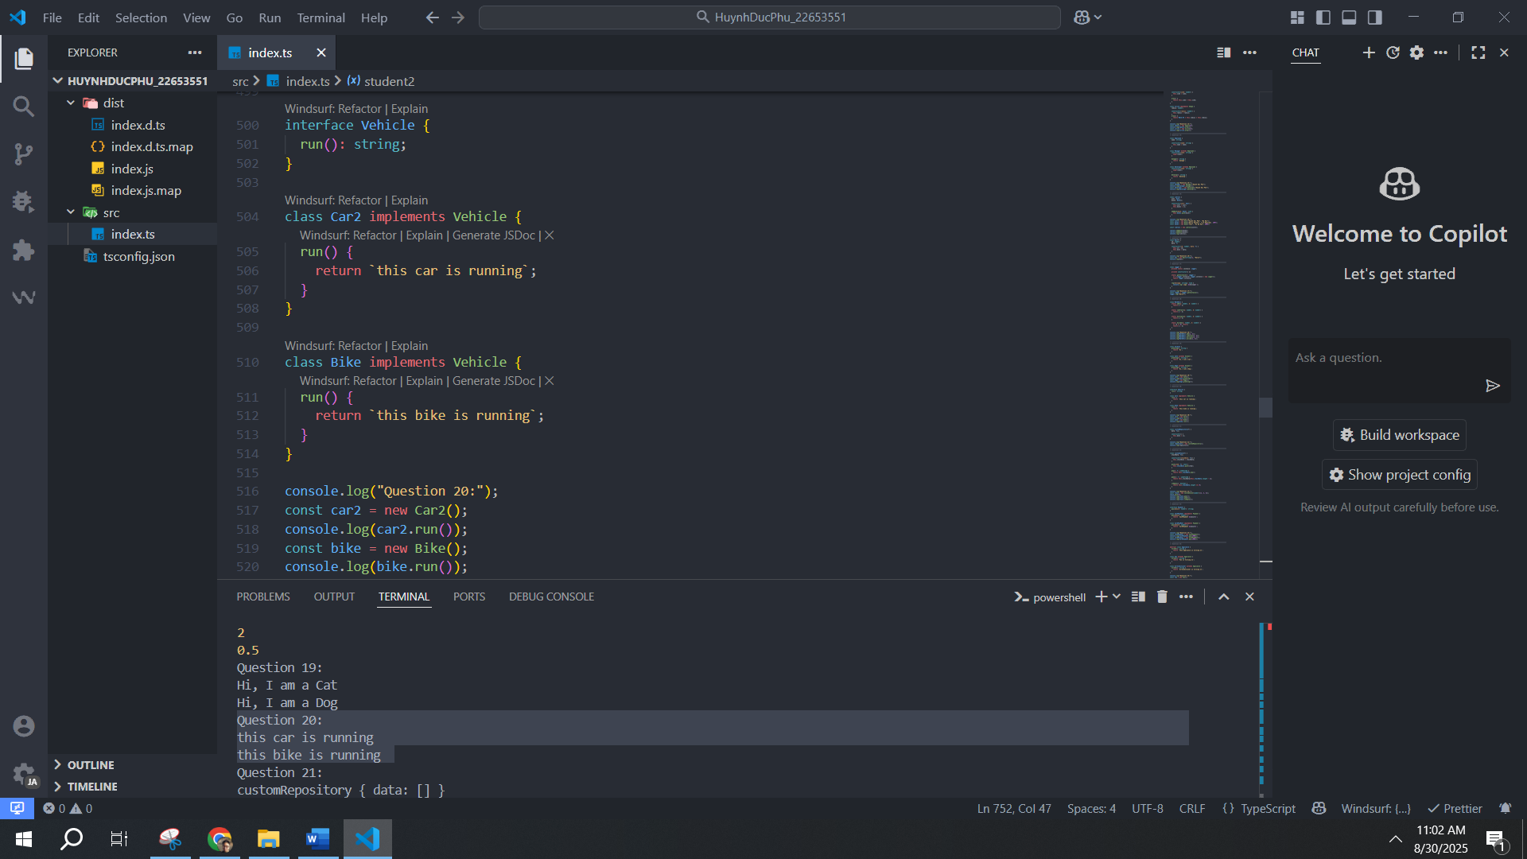
21. Create a generic Repository class with methods add(), getAll().
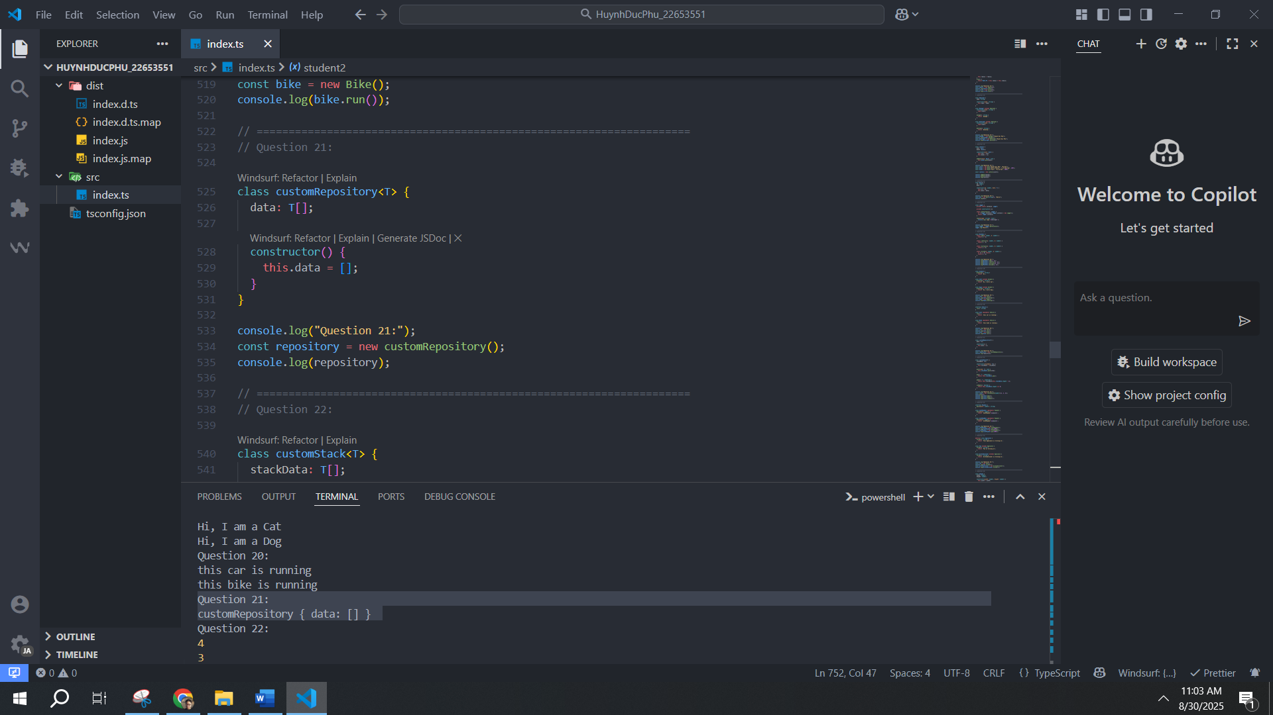
22. Create a class Stack with push, pop, peek, isEmpty methods.
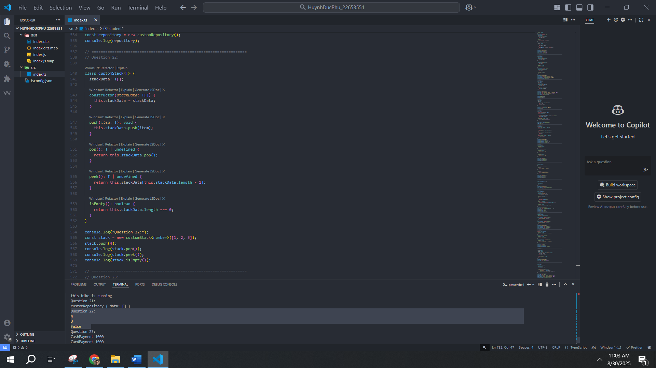
23. Create an interface Payment with method pay(amount). Implement CashPayment and
CardPayment.
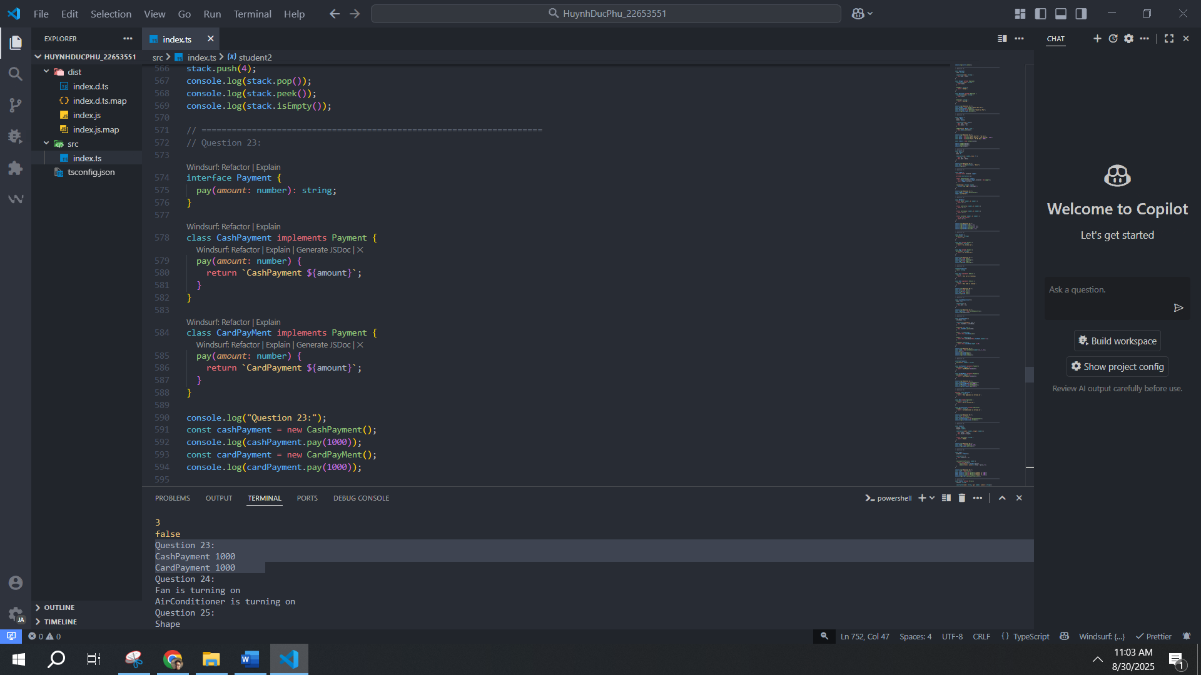
24. Create an abstract class Appliance with method turnOn(). Implement Fan and AirConditioner.
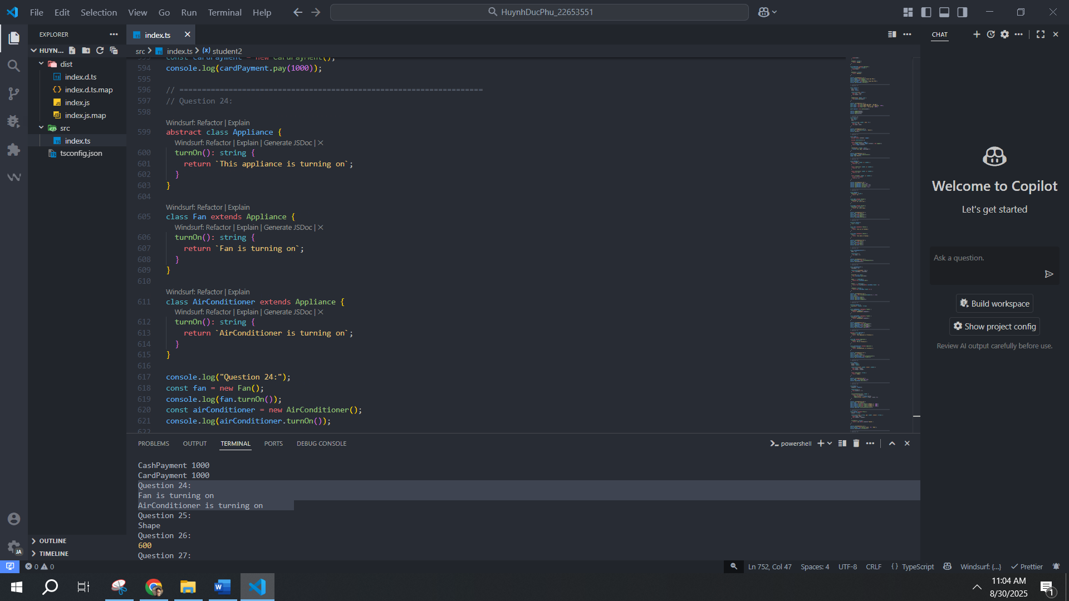
25. Create a class Shape with a static method describe().
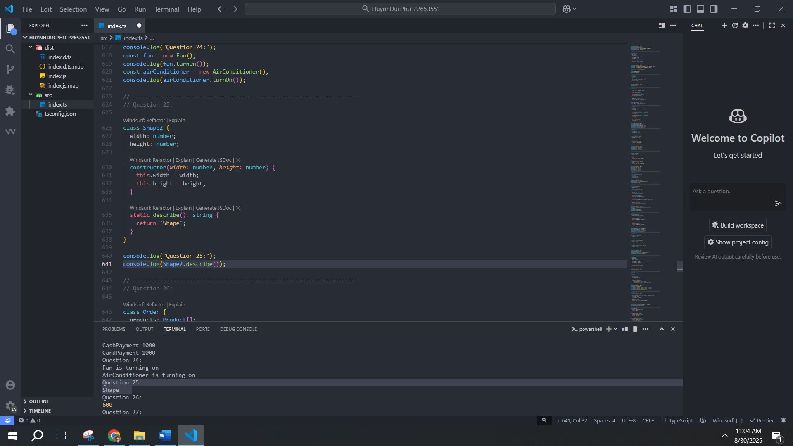
26. Create a class Order with list of products. Add method to calculate total price.
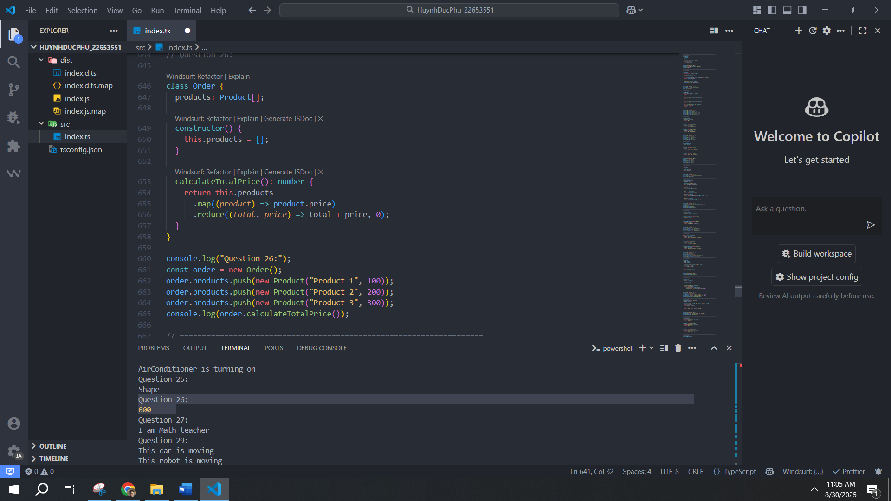
27. Create a class Teacher that extends Person. Add subject attribute and introduce method.
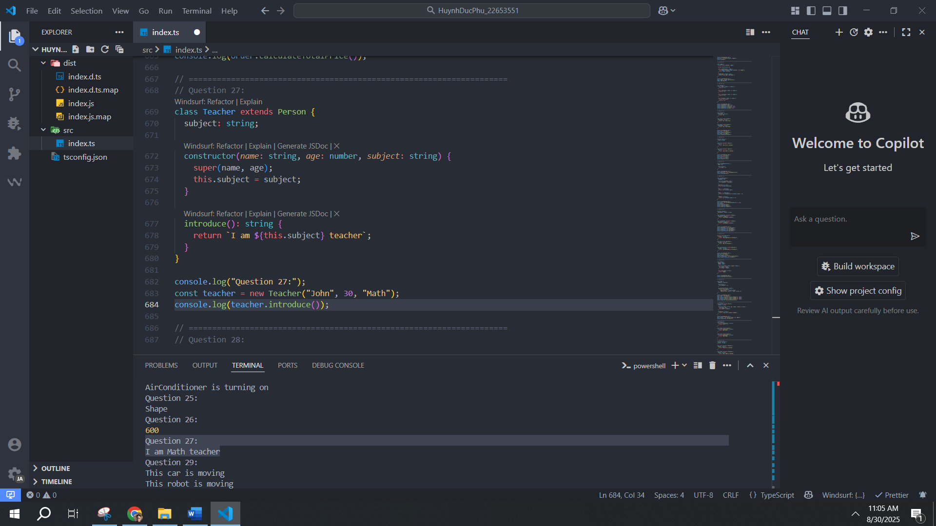
28. Create a class Animal with protected method makeSound(). Extend Dog and Cat to override it.
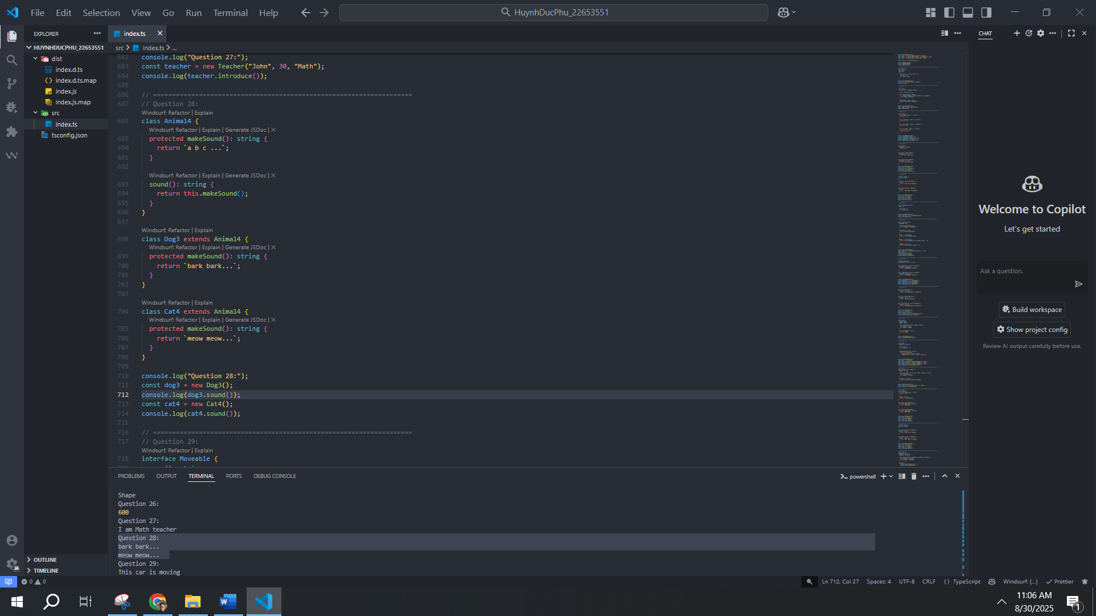
29. Create an interface Movable with method move(). Implement it in Car and Robot.
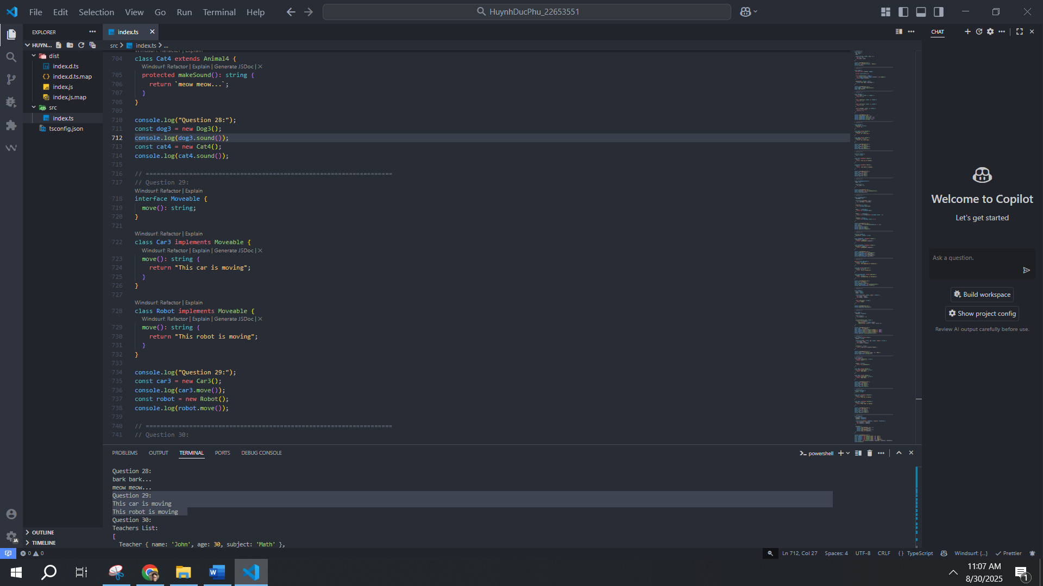
30. Create a class School with list of Students and Teachers. Add method to display info.
